Lab: Objects and Classes
Problems with exercise and homework for the "JS Front-End" Course @ SoftUni.
Submit your solutions in the SoftUni judge system at https://judge.softuni.org/Contests/3791/Objects-and-Classes-Lab

Person Info
Write a function that receives 3 parameters, sets them to an object, and returns that object.
The input comes as 3 separate strings in the following order: firstName, lastName, age.

Examples
Input | Object Properties
"Peter",  "Pan",  "20" | firstName: Peter  lastName: Pan  age: 20
"George",  "Smith",  "18" | firstName: George  lastName: Smith  age: 18

Hints
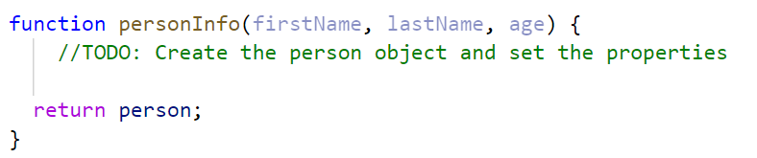

City
Write a function that receives a single parameter – an object, containing five properties:
{ name, area, population, country, postcode }
Loop through all the keys and print them with their values in format: "{key} -> {value}"
See the examples below.

Examples
Input | Output
{  name: "Sofia",  area: 492,  population: 1238438,  country: "Bulgaria",  postCode: "1000"  } | name -> Sofia  area -> 492  population -> 1238438  country -> Bulgaria  postCode -> 1000
{  name: "Plovdiv",  area: 389,  population: 1162358,  country: "Bulgaria",  postCode: "4000"  } | name -> Plovdiv  area -> 389  population -> 1162358  country -> Bulgaria  postCode -> 4000

Convert to Object
Write a function that receives a string in JSON format and converts it to an object.
Loop through all the keys and print them with their values in format: "{key}: {value}"

Examples
Input | Output
'{"name": "George", "age": 40, "town": "Sofia"}' | name: George  age: 40  town: Sofia
'{"name": "Peter", "age": 35, "town": "Plovdiv"}' | name: Peter  age: 35  town: Plovdiv

Hints
- Use JSON.parse() method to parse JSON string to an object
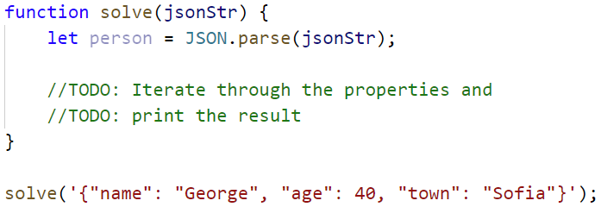

Convert to JSON
Write a function that receives a first name, last name, hair color and sets them to an object.
Convert the object to JSON string and print it.
Input is provided as 3 single strings in the order stated above.

Examples
Input | Output
'George', 'Jones', 'Brown' | {"name":"George","lastName":"Jones","hairColor":"Brown"}
'Peter', 'Smith', 'Blond' | {"name":"Peter","lastName":"Smith","hairColor":"Blond"}

Hints
- Use JSON.stringify() to parse the object to JSON string
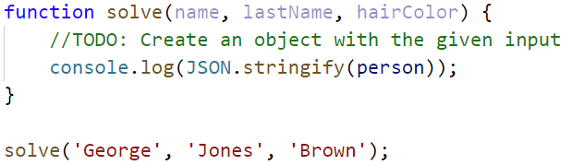

Phone Book
Write a function that stores information about a person’s name and phone number. The input is an array of strings with space-separated name and number. Replace duplicate names. Print the result as shown.

Example
Input | Output
['Tim 0834212554',  'Peter 0877547887',  'Bill 0896543112',  'Tim 0876566344'] | Tim -> 0876566344  Peter -> 0877547887  Bill -> 0896543112
['George 0552554',  'Peter 087587',  'George 0453112',  'Bill 0845344'] | George -> 0453112  Peter -> 087587  Bill -> 0845344

Meetings
Write a function that manages meeting appointments. The input comes as an array of strings. Each string contains a weekday and person’s name. For each successful meeting, print a message. If you receive the same weekday twice, the meeting cannot be scheduled so print a conflicting message. In the end, print a list of all successful meetings.

Example
Input | Output
['Monday Peter',  'Wednesday Bill',  'Monday Tim',  'Friday Tim'] | Scheduled for Monday  Scheduled for Wednesday  Conflict on Monday!  Scheduled for Friday  Monday -> Peter  Wednesday -> Bill  Friday -> Tim
['Friday Bob',  'Saturday Ted',  'Monday Bill',  'Monday John',  'Wednesday George'] | Scheduled for Friday  Scheduled for Saturday  Scheduled for Monday  Conflict on Monday!  Scheduled for Wednesday  Friday -> Bob  Saturday -> Ted  Monday -> Bill  Wednesday -> George

Address Book
Write a function that stores information about a person’s name and his address. The input comes as an array of strings. Each string contains the name and the address separated by a colon. If you receive the same name twice just replace the address. In the end, print the full list, sorted alphabetically by the person’s name.
Input | Output
['Tim:Doe Crossing',  'Bill:Nelson Place',  'Peter:Carlyle Ave',  'Bill:Ornery Rd'] | Bill -> Ornery Rd  Peter -> Carlyle Ave  Tim -> Doe Crossing
['Bob:Huxley Rd',  'John:Milwaukee Crossing',  'Peter:Fordem Ave',  'Bob:Redwing Ave',  'George:Mesta Crossing',  'Ted:Gateway Way',  'Bill:Gateway Way',  'John:Grover Rd',  'Peter:Huxley Rd',  'Jeff:Gateway Way',  'Jeff:Huxley Rd'] | Bill -> Gateway Way  Bob -> Redwing Ave  George -> Mesta Crossing  Jeff -> Huxley Rd  John -> Grover Rd  Peter -> Huxley Rd  Ted -> Gateway Way

Cats
Write a function that receives array of strings in the following format '{cat name} {age}'.
Create a Cat class that receives in the constructor the name and the age parsed from the input.
It should also have a method named "meow" that will print "{cat name}, age {age} says Meow" on the console.
For each of the strings provided, you must create a cat object and invoke the .meow () method.

Examples
Input | Output
['Mellow 2', 'Tom 5'] | Mellow, age 2 says Meow  Tom, age 5 says Meow
['Candy 1', 'Poppy 3', 'Nyx 2'] | Candy, age 1 says Meow  Poppy, age 3 says Meow  Nyx, age 2 says Meow

Hints
- Create a Cat class with properties and methods described above.
- Parse the input data.
- Create all objects using the class constructor and the parsed input data, store them in an array.
- Loop through the array using for…of a cycle and invoke .meow() method.
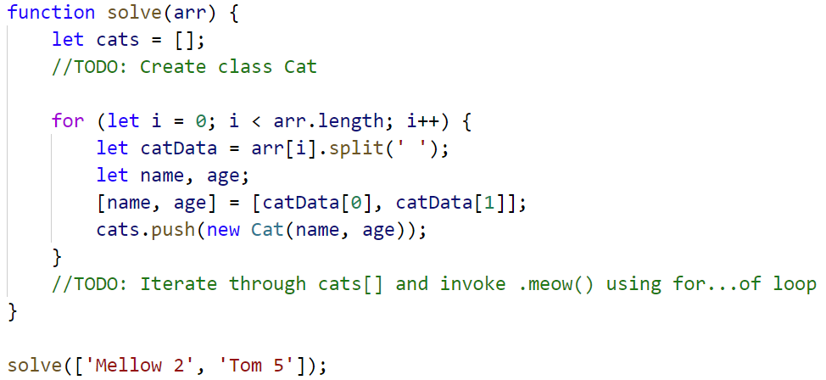

Songs
Define a class Song, which holds the following information about songs: typeList, name, and time.
You will receive the input as an array.
The first element n will be the number of songs. Next n elements will be the songs data in the following format: "{typeList}_{name}_{time}", and the last element will be typeList / "all".
Print only the names of the songs, which have the same typeList (obtained as the last parameter). If the value of the last element is "all", print the names of all the songs.

Examples
Input | Output
[3,  'favourite_DownTown_3:14',  'favourite_Kiss_4:16',  'favourite_Smooth Criminal_4:01',  'favourite'] | DownTown  Kiss  Smooth Criminal
[4,  'favourite_DownTown_3:14',  'listenLater_Andalouse_3:24',  'favourite_In To The Night_3:58',  'favourite_Live It Up_3:48',  'listenLater'] | Andalouse
[2,  'like_Replay_3:15',  'ban_Photoshop_3:48',  'all'] | Replay  Photoshop

Solution:
Create a Song class with properties described above
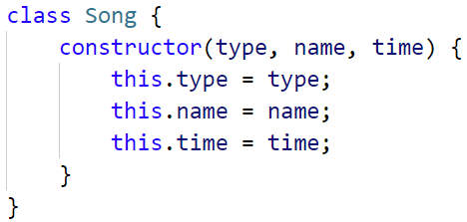
Create a new array, where you will store songs
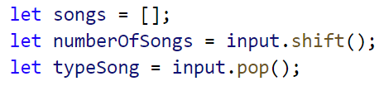
Iterate over the songs:
